9. Risk Analysis
The thesis has one dominant risk and three secondary ones. Dominant: Organon’s established-brands cash flow declining faster than modelled, which breaks the deleveraging math. Secondary: refinancing the ~$9.5bn bridge, the Nexplanon sales-practice probe, and biosimilar price erosion. Every other risk is manageable. The valuation’s ~15–20% margin of safety and Organon’s high cash conversion are the buffers.

9.1 Risk heatmap
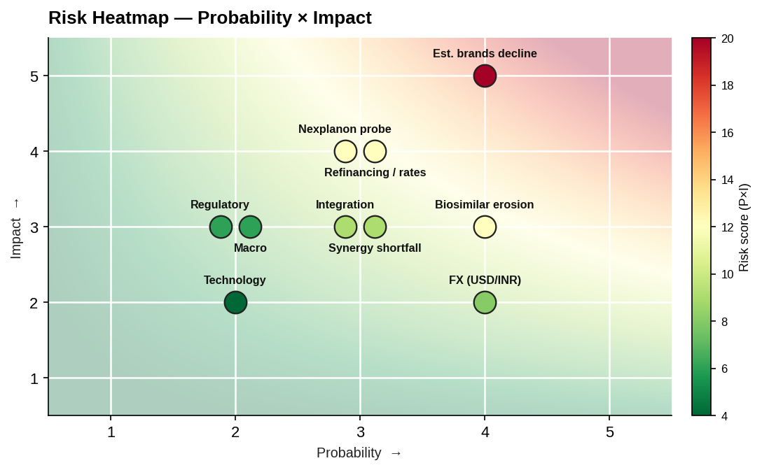
Risk heatmap — probability × impact
Four risks sit in the high-priority zone (score ≥12): established-brands decline, refinancing/rates, the Nexplanon probe, and biosimilar erosion. The full register — probability, impact, score and mitigation for each — is in Risk_Register.xlsx.

9.2 Risk categories
Commercial — HIGH. ~59% of Organon revenue is established brands in secular decline. Faster erosion directly cuts the EBITDA that services the debt. Mitigant: mix shift to Women’s Health/Biosimilars; the low ~6.2x entry multiple prices in decline.
Regulatory — LOW/MEDIUM. Antitrust risk is low (limited product overlap). The live items are multi-jurisdiction competition filings and India outbound-investment approvals; both are process, not existential.
Execution — MEDIUM. Delivering >$350m of synergies on schedule. Mitigant: procurement-led quick wins; conservative 30/70/100 phasing.
Integration — MEDIUM. An Indian acquirer integrating a large US-listed multinational — systems, talent retention, governance. Mitigant: dedicated integration office; retain Organon’s commercial organisation.
Macroeconomic — LOW/MEDIUM. Pharma demand is defensive; geographic diversification cushions. Rate cycle matters mainly via financing (below).
Currency — MEDIUM. USD/INR and EUR exposure. Mitigant: USD-denominated debt is largely matched to Organon’s USD cash flows (natural hedge); residual INR exposure at the parent.
Financing — HIGH. The ~$9.5bn bridge must be termed out into bonds/loans. A rate or spread shock between signing and take-out raises blended cost toward Organon’s asset yield and compresses returns. Mitigant: committed bridge de-risks closing; term out early; hedge.
Litigation — MEDIUM/HIGH. The Nexplanon sales-practice probe (Ch.3) casts doubt on Women’s Health revenue quality and carries legal/reputational exposure. Mitigant: diligence, reps & warranties, indemnity/escrow, price protection.
Competition — HIGH. Biosimilars are a price-erosion business; more entrants compress margins. Mitigant: Sun’s low-cost, API-integrated manufacturing is the structural edge.
Technology — LOW. Limited reliance on unproven pipeline; the portfolio is established. Manageable.

9.3 Value sensitivity — tornado
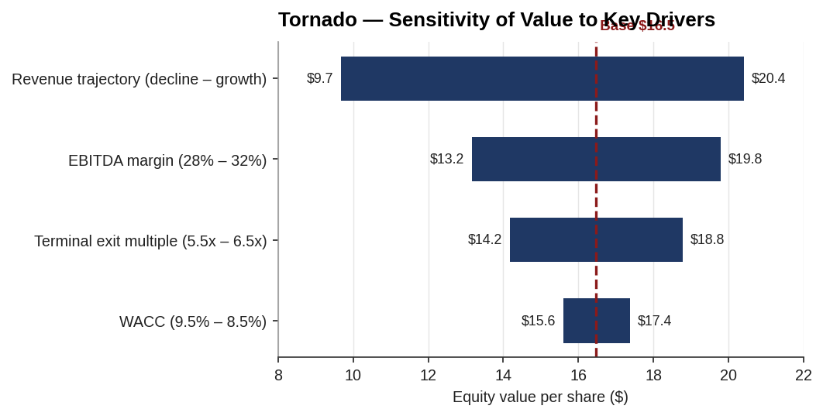
Tornado — sensitivity of value to key drivers
Standalone equity value (base ~$16.5/share) is most sensitive to the terminal exit multiple and the revenue trajectory — i.e., to how the market ultimately capitalises a declining-brands business and how fast that base erodes. Margin and WACC matter less. This confirms the commercial risk (decline) as the binding variable, not the discount rate.

9.4 Key-risk deep dives
(1) Established-brands decline. At −4%/yr (vs ~flat base), standalone value falls toward the low end of the football field and combined FCF weakens — the case that most threatens the deleveraging path. This is the single risk to underwrite hardest.
(2) Refinancing the bridge. ~$9.5bn must be refinanced. Every +100 bps on the permanent debt is ~$95m of pre-tax interest (~$77m after-tax) — meaningful against combined earnings and the deleveraging schedule. The committed bridge removes closing risk but not take-out-pricing risk.
(3) Nexplanon probe. Channel-stuffing findings imply some reported Women’s Health revenue was pulled forward. If underlying demand is lower, both the growth franchise and the valuation base are weaker than they appear — hence the emphasis on reps, warranties and indemnities.

9.5 Risk conclusion
The risk profile is concentrated, not diffuse: get the established-brands decline and the bridge refinancing right and the deal works; miss on either and the leverage that made it accretive becomes the problem. The mitigants — a low entry multiple, high cash conversion, a committed bridge, and contractual protection on the Nexplanon issue — are adequate but not abundant. Net: an acceptable, underwrite-able risk profile, conditional on disciplined diligence and financing execution.

Assumptions & sources
- Probability/impact scores (1–5) are analyst judgement; register and scores in Risk_Register.xlsx.
- Tornado computed from the Ch.7 DCF: exit multiple 5.5–6.5x, revenue −4%/yr to +1.5%/yr, margin 28–32%, WACC 8.5–9.5%; base $16.5/share.
- Refinancing sensitivity: +100 bps on ~$9.5bn ≈ $95m pre-tax / ~$77m after-tax.
- Nexplanon probe per company disclosure (Oct 2025) and reporting.
Sources: prior chapters; Organon disclosures (Nexplanon probe); FRED (rates). Full map in 05_Data/DATA_SOURCES.docx.

